***Achieving the Grand Challenge Vision***

**\*\*\* GRAND CHALLENGE VISION \*\*\***

***Transform agriculture to deliver a 20 percent increase in quality food availability at a 20 percent lower environmental impact by 2025***

The **Grand Challenge Process** (Figure 4) was developed to facilitate achieving the **Grand Challenge Vision**. The core of ARS is its **Scientists** with work organized by **Research Projects.** Scientists from diverse disciplines and across National Programs will collaborate with their National Program Leaders to develop **Focus Areas** and form **Focus Teams** that address agricultural problems of national and strategic importance. Focus Areas use a GxExMxP systems approach to emphasize cross disciplinary research. The overall Vision will be achieved by many different Focus Areas all working on a different facet of the Vision. The **Grand Challenge Leadership Council** directs the overall **Grand Challenge Process** by removing barriers, facilitating work, communicating progress, and supporting data system development.

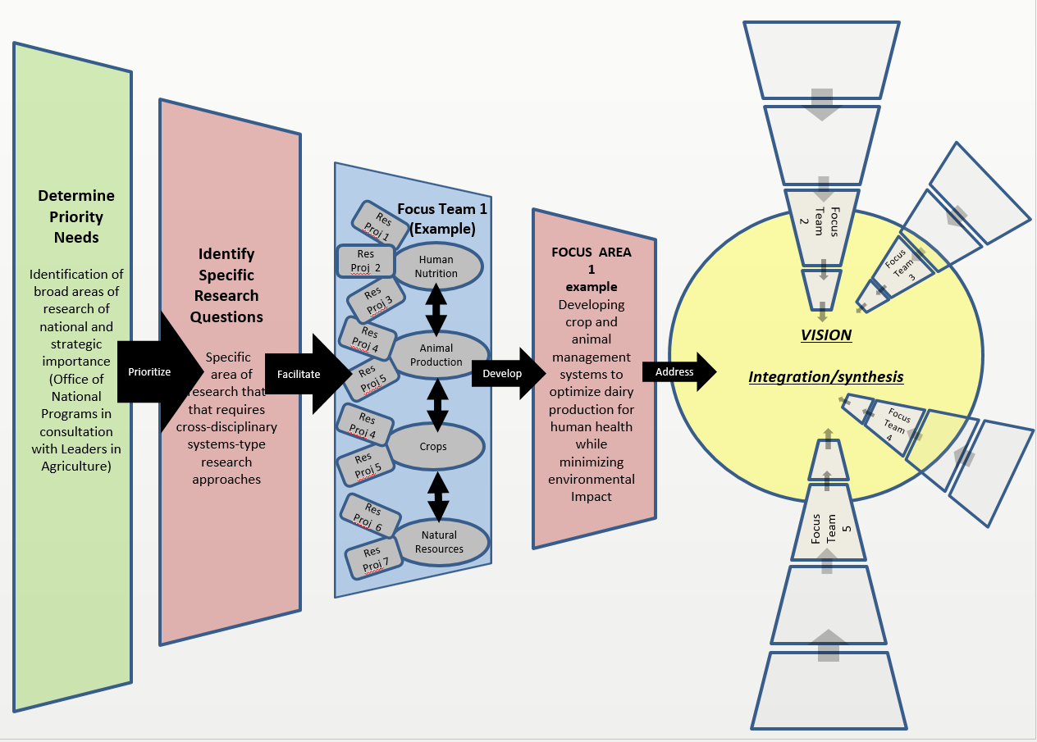

Figure 4. The Grand Challenge Process

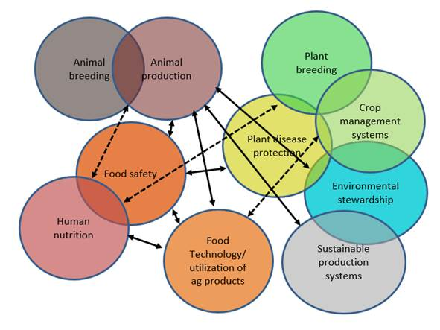 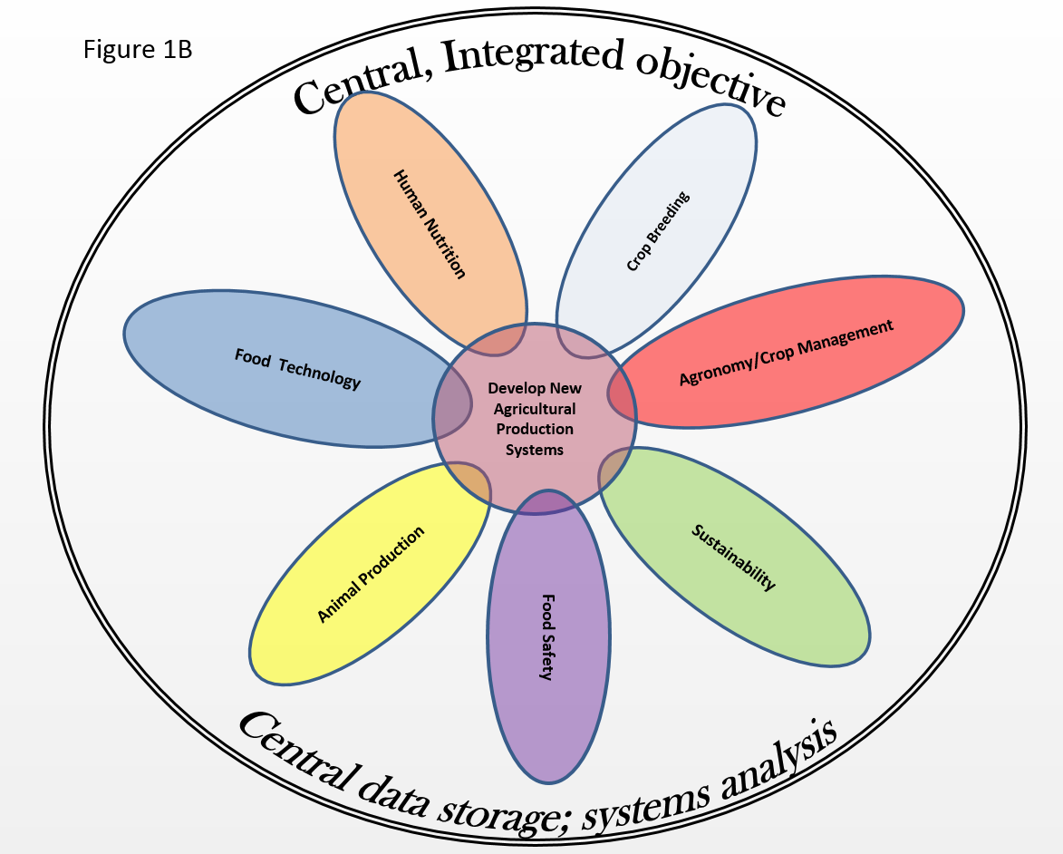

Research in ARS; Left as it is presently; Right as proposed.

Focus Areas are built:

* Across National Programs
* Around multidisciplinary strategic questions, not areas of general research interest;
* Around the knowledge and skills of all the Focus Team members;
* With strong plans that are either adapted from existing project plans or are put into new project plans; and
* Using a GxExMxP (GeneticsXEnvironmentXManagementXPostharvest factors including nutrition) systems approach, including central data collection and statistical meta-analyses.

Successfully addressing the Grand Challenge vision may require many Focus Areas and Teams, and it is incumbent on National Program Leadership to coordinate these Focus Areas in a manner that focuses on truly strategic problems without creating unnecessary redundancies in research. NPLs also will be essential for identifying research gaps and facilitating development of new Focus Areas.